**The Tuckman Model of Team Development**

*Revised Version: Arfaz Hossain*

The Tuckman Model, proposed by Bruce Tuckman in 1965, describes 5 stages of team development: the forming, storming, norming, performing, and the adjourning stage. These stages may appear to follow a linear path, in reality, teams can cycle through these stages multiple times, especially during events like addition of a new team member or lack of effective communication between team members. Stalling in one stage for too long may cause a team to never realize the absolute full and complete potential of reaching the performing stage. [1]

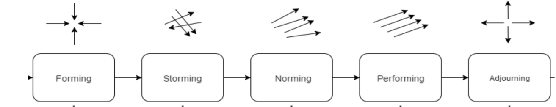

The forming stage happens when everyone in the team gets to know each other. Creating a Team Charter and setting the guidelines, expectations and proves to effectively guide all team members during this stage. Engaging in a fun team forming activity can help the team in getting to know the different strengths and weaknesses of everyone in the team.

If a team encounters conflict among members due to changing expectations set in the forming stage, they have entered the storming stage. When everyone in the team tries to contribute differently through competing to push for potential ideas or while trying to determine their role in the team, conflict may arise among team members. Learning to harness constructive conflict and compromise can facilitate early progression to the next stage.

In the norming stage, team members resolve conflicts and begin working on their respective roles. People sometimes work independently, while checking in with teammates frequently to maintain an effective and efficient workflow of the project. Group cohesion plays a crucial role in ensuring that everyone within the team feels responsible not only for the task but also for each other's success. Team development might move backwards to the forming or storming stage, if teammates fail to act according to their role, or fail to follow the team expectations and the overall team goal.

Teams working together for the first time may struggle to reach the performing stage, as it often takes several projects to develop an internal system that allows for smooth and efficient collaboration. In the adjourning stage, the last of the development stages, team members go their separate ways, which can be emotional for many. In all the 5 stages of the team development project, communication plays an important and critical key role in maintaining the group cohesion as well as in maintaining an effective project workflow, and eventually in reaching the overall success of the team.

[1] S. McCahan, *et al*., “Introduction to Teamwork,” in *Designing Engineers: An Introductory Text*. Wiley, 2015, pp. 219-246